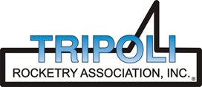
Tripoli Motor Testing Division
223 NC Highway 54 West
Chapel Hill, NC 27514
(919) 357 5681 (c)
April 16, 2024

Scott Kormeier
Loki Research, LLC
119 Mowrey Ln.
Theodosia, MO 65761

Dear Mr. Kormeier,

The Loki Research N5500LW reload kit was tested on March 30, 2024 and complies with NFPA 1125. The motor is certified for hobby rocketry use by the members of the Tripoli Rocketry Association and all approving organizations with reciprocal certifying agreements.

Motor Manufacturer Loki Research, LLC
Manufacturer’s Designation N5500 LW [made for the CTI Pro-98 6g XL hardware]
Propellant Loki White
TMT Nomenclature 19,137 N5344

Diameter 3.868” 98.25 mm
Overall Length 54.438” 1382.7 mm
Outside the MMT 3.25” 82.55 mm

Loaded Mass 32.75 lb 14,855 g
Propellant Mass 20.243 lb* 9182 g*
Burnout Mass 12.75 lb 5783.39 g
* = data provided by manufacturer

Burn time 3.513, 3.646 sec [avg = 3.58 sec]

Total Impulse 4219.8, 4384.4 lbf.s 18,771, 19,503 N.s
[4302.1 lbf.s] [19,137 N.s]

Max Impulse 1487.3, 1515.2 lbf 6615.8, 6739.7 N
[1501.3 lbf] [6677.8 N]

Average Impulse 1200.7, 1201.8 lbf 5340.8, 5346.1 N
[1201.3 lbf] [5343.5 N]
Number of Motors Tested 2

Nominal Measured
Delay Time Data n.a. n.a.

Casing Temp. [NFPA 1125 7.4.1] Passed

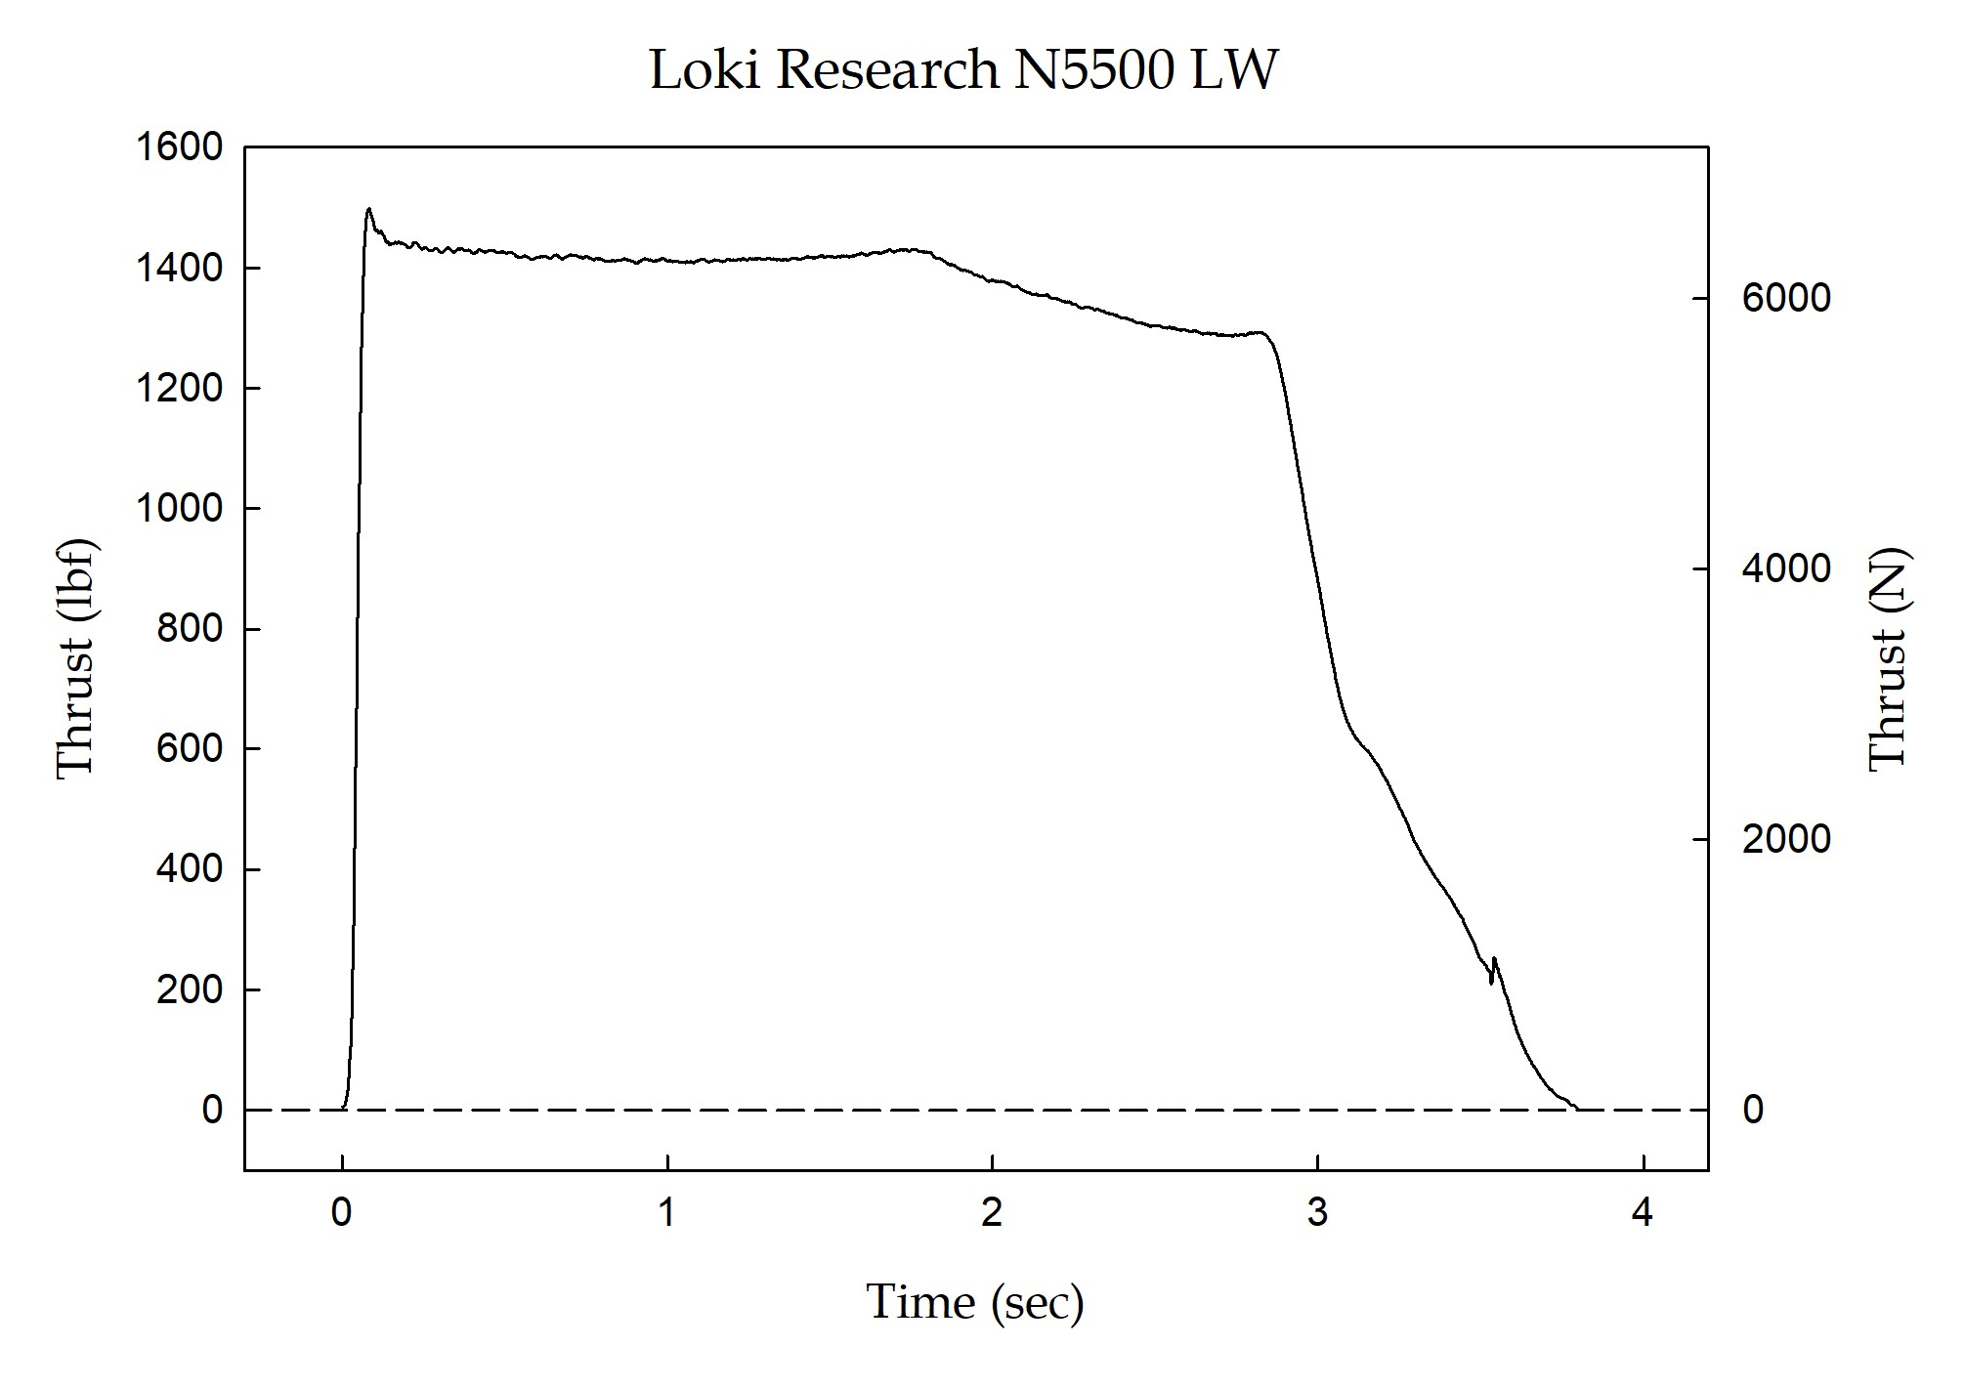

Sincerely,

Alan C. Whitmore
Chair, Tripoli Motor Testing

